
DIGITAL SIGNAL PROCESSING MINI-PROJECT REPORT

ON

“DIGITAL AUDIO EQUALIZER USING MATLAB”

Under the Course
PROJECT BASED EXPERIENTIAL LEARNING

SUBMITTED BY

PRN | NAME OF STUDENT
1022512002 | Parvez Nadaf
1022512008 | Sarvadnya Kathe

2026-27
THIRD Year Electronics and Communication Engineering (TY ECE)
Division:B , Semester - V

Under the Guidance Of
MENTOR NAME (Dr. Hrishikesh Vanjari)

Department of Electronics and Communication Engineering
School of Engineering and Technology
DES Pune University, Pune.
2026-2027
Program: B. Tech Electronics and Communication Engineering
School of Engineering and Technology
DES Pune University, Pune

CERTIFICATE

This is to certify that student Parvez Nadaf, Sarvadnya Kathe PRNs. 1022512002,1022512008 is studying in TY ECE (Division:B) course in SEM V and they have successfully completed and submitted the ‘DIGITAL AUDIO EQUALIZER USING MATLAB’ Report under the Course “DIGITAL SIGNAL PROCESSING” This study is a partial fulfillment of the degree of Bachelor of Technology in Electronics and Communication Engineering of DES Pune University, Pune during the academic year 2026-2027.

Dr. Hrishikesh Vanjari Dr. PRACHI JOSHI

Mentor HoS

ACKNOWLEDGMENT

I would like to express my sincere gratitude to everyone who has supported and guided me throughout the successful completion of my project, “Digital Audio Equalizer Using MATLAB.” This project has been a valuable learning experience, helping me strengthen my understanding of Digital Signal Processing (DSP), digital filter design, and audio signal analysis.

First and foremost, I would like to thank my project mentor Dr. Hrishikesh Vanjari for providing valuable guidance, continuous encouragement, and constructive suggestions at every stage of the project. Their support and guidance helped me understand the concepts involved, overcome technical challenges, and complete the project successfully.

I am deeply grateful to Dr. Prachi Joshi, Head of the School (HoS), for her encouragement and for providing a supportive academic environment. I would also like to express my sincere thanks to the Department of Electronics and Communication Engineering and the School of Engineering and Technology, DES Pune University, Pune, for providing the necessary facilities, resources, and opportunities to carry out this project.

I extend my heartfelt thanks to all the faculty members for their valuable suggestions, academic support, and motivation throughout the project work. I am also thankful to my classmates and friends for their cooperation, discussions, and encouragement, which contributed to my learning and progress.

Finally, I would like to thank everyone who directly or indirectly contributed to the successful completion of this project. Their support and encouragement have been instrumental in making this project a meaningful and enriching academic experience.

ABSTRACT

Digital Signal Processing (DSP) is widely used in modern audio systems to analyze, modify, and improve sound quality. One of its important applications is audio equalization, which allows different frequency components of an audio signal to be adjusted independently. The project “Digital Audio Equalizer Using MATLAB” focuses on the design and implementation of a three-band digital audio equalizer using MATLAB. The main objective is to understand the principles of digital filtering and demonstrate how bass, midrange, and treble components can be controlled to achieve the desired audio characteristics.
The proposed system divides the input audio signal into three frequency bands: low-frequency (bass), mid-frequency (midrange), and high-frequency (treble). A fourth-order Butterworth low-pass filter with a cutoff frequency of 250 Hz is used to extract the bass component, while a fourth-order Butterworth high-pass filter with a cutoff frequency of 4 kHz extracts the treble component. The midrange component is obtained by subtracting the bass and treble components from the original signal. Separate gain values are applied to each band before the modified signals are recombined to generate the equalized output.
In this project, the bass gain is set to +6 dB, the midrange gain to 0 dB, and the treble gain to −3 dB. These settings demonstrate bass enhancement, preservation of the midrange, and reduction of high-frequency content. MATLAB is used for filter design, signal generation, frequency-band separation, gain adjustment, and graphical analysis. A synthetic test signal with a sampling frequency of 44.1 kHz and a duration of five seconds is generated using sinusoidal components at 100 Hz, 1 kHz, and 8 kHz to represent the three frequency regions.
The performance of the equalizer is examined using time-domain waveforms, frequency spectra, and filter frequency-response plots. Root mean square (RMS) amplitude and peak amplitude are also considered to observe changes between the input and output signals. These analyses help illustrate the effects of filtering and gain adjustment on the signal's frequency components.
The project demonstrates the practical implementation of digital filters and frequency-band processing using MATLAB. It provides a clear understanding of how audio equalization works and establishes a foundation for further development of interactive and real-time audio processing systems. The proposed design can be useful for learning DSP concepts and understanding their applications in music systems, multimedia devices, and audio enhancement applications.

INDEX

CHAPTER NO. |  | TOPIC
1 |  |  | Introduction
 | 1.1 |  | Background
 | 1.2 |  | Need/Importance
 | 1.3 |  | Objectives
 | 1.4 |  | Scope
2 |  |  | Literature Review
 | 2.1 |  | Relevant concepts, theories
 | 2.2 |  | Technologies related to the project
 | 2.3 |  | Summary of similar works or case studies
3 |  |  | Proposed Methodology
 | 3.1 |  | System Overview
 | 3.2 |  | Architecture / Workflow Diagram
 | 3.3 |  | Data Collection / Input Description
 | 3.4 |  | Algorithms / Techniques Used
 | 3.5 |  | Tools, software, or equipment used if any
 | 3.6 |  | Module-wise Implementation Plan
 | 3.7 |  | Validation and Testing Strategy
4 |  |  | Weekly Log Book Entries
5 |  |  | Results / Observations
 |  | 5.1 | Experimental / Implementation Setup
6 |  | 5.2 | Performance Metrics
 |  | 5.3 | Comparison with Expected Results
 |  | 5.4 | Observations and Analysis
 |  | 5.5 | Validation and Verification with summary of findings
7 |  |  | Future Enhancement
8 |  |  | Conclusion & Recommendations
 |  |  | References / Bibliography

CHAPTER 1: INTRODUCTION

1.1 Background
Digital Signal Processing (DSP) is the analysis and modification of signals represented as sequences of numbers. Audio signals contain components at different frequencies. Low-frequency components are commonly perceived as bass, middle-frequency components as midrange, and high-frequency components as treble. An audio equalizer adjusts the relative levels of these frequency regions to change the tonal balance of the sound.
A digital equalizer can be implemented by splitting an input signal into frequency bands using digital filters, multiplying each band by a gain, and adding the modified bands together. MATLAB provides tools for generating signals, designing filters, analysing spectra, plotting results, and writing audio files.

1.2 Need / Importance
The project provides a practical demonstration of core DSP topics: sampling, digital filtering, frequency response, amplitude gain in decibels, signal reconstruction, and quantitative evaluation. It also provides a reproducible test setup that does not depend on a particular external music file. The same approach can be adapted for audio enhancement, tone control, and educational demonstrations.

1.3 Objectives
Design a three-band digital audio equalizer using MATLAB.
Separate bass and treble using low-pass and high-pass Butterworth filters.
Obtain the midrange component as the residual signal.
Apply independent gain settings to bass, midrange, and treble.
Compare input and output waveforms and frequency spectra.
Measure RMS amplitude and peak amplitude and save the equalized audio.

1.4 Scope
The project focuses on offline processing of a mono audio signal using three broad frequency regions. The example uses a 250 Hz bass cutoff, a 4 kHz treble cutoff, and gains of +6 dB, 0 dB, and −3 dB respectively. It includes signal generation or WAV-file input, filtering, gain adjustment, plotting, measurement, and audio export. It is not a real-time streaming equalizer and does not evaluate perceived audio quality through formal listening tests.

CHAPTER 2: LITERATURE REVIEW

2.1 Relevant Concepts and Theories
A discrete-time audio signal is represented as x[n], where n is the sample index. The sampling frequency determines how many samples are acquired per second. In this project the sampling frequency is 44,100 Hz, a common audio sampling rate.
A low-pass filter passes low frequencies and attenuates frequencies above its cutoff region. A high-pass filter passes high frequencies and attenuates lower frequencies. The Butterworth response is selected because it has a maximally flat magnitude response in the passband. The implemented filters are fourth order.
The midrange component is calculated as m[n] = x[n] − b[n] − t[n], where b[n] is the bass output and t[n] is the treble output. Therefore, before applying gain, the three branches sum back to the input, subject to numerical precision.
Gain in decibels is converted to a linear amplitude multiplier using G = 10^(G_dB/20). A +6 dB gain corresponds to approximately 1.995 times amplitude, 0 dB corresponds to 1, and −3 dB corresponds to approximately 0.708.
The equalized output is y[n] = G_b b[n] + G_m m[n] + G_t t[n]. RMS amplitude is calculated as sqrt((1/N) Σ x[n]^2), and peak amplitude is max |x[n]|. RMS indicates an overall signal level, while peak amplitude indicates the largest absolute sample.

2.2 Technologies Related to the Project
MATLAB: used for numerical computation, signal generation, filter design, plotting, and audio file handling.
Signal Processing Toolbox: provides filter-design and frequency-response functions such as butter and freqz.
audioread / audiowrite: read and write WAV audio files.
filtfilt: applies forward-backward filtering to provide zero-phase offline filtering.
FFT: used to estimate and display the magnitude spectrum of the input and output.

2.3 Summary of Similar Work or Case Studies
Audio equalizers commonly use low-pass, high-pass, and band-pass filters or filter banks to adjust frequency-dependent gain. Graphic equalizers provide multiple fixed frequency bands, while parametric equalizers offer control over centre frequency, bandwidth, and gain. This project uses a deliberately simple three-band structure suitable for demonstrating the basic DSP principles. It is not intended to match the complexity of commercial multi-band or parametric equalizers.
The supplied project report references Orfanidis (2005) on high-order digital parametric equalizer design and MathWorks documentation on equalization and graphic equalization. These references provide further context for more advanced designs.

CHAPTER 3: PROPOSED METHODOLOGY

3.1 System Overview
The system accepts a WAV file or generates a synthetic test signal. The signal is converted to mono if necessary and normalized. Fourth-order Butterworth low-pass and high-pass filters extract bass and treble. The midrange is calculated by subtracting these two branches from the input. The three branches are multiplied by the selected gains and added together. The program then plots the signals and spectrum, calculates performance measurements, and writes the output audio and result figures.

3.2 Architecture / Workflow Diagram
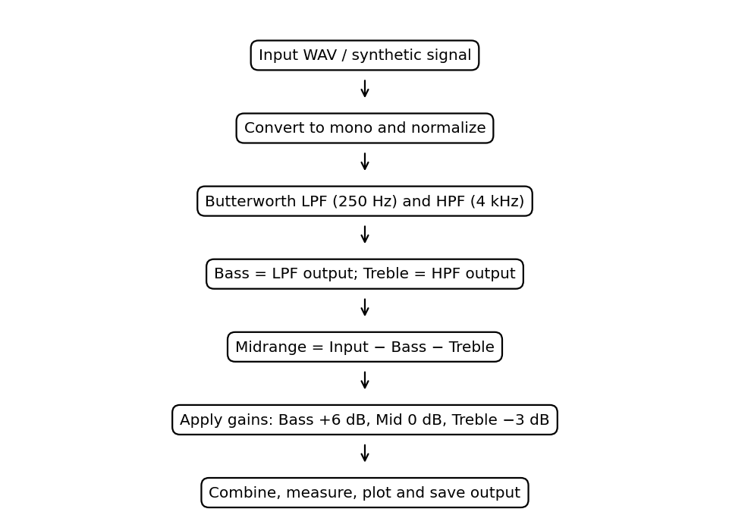

Figure 1: Workflow of the three-band digital audio equalizer.

3.3 Data Collection / Input Description
The supplied test signal is synthetic, five seconds long, and sampled at 44,100 Hz. It contains sinusoidal components at 100 Hz, 1 kHz, and 8 kHz, representing bass, midrange, and treble content. A slowly varying amplitude envelope and low-level random noise make the signal less idealized. The total sample count is 5 × 44,100 = 220,500 samples. The project description indicates a WAV input and an optional CSV file containing time and amplitude.

3.4 Algorithms / Techniques Used
Read the input audio using audioread, or generate the synthetic test signal.
Convert stereo input to mono where required and normalize the signal for processing.
Design a fourth-order Butterworth low-pass filter with a nominal 250 Hz cutoff.
Design a fourth-order Butterworth high-pass filter with a nominal 4,000 Hz cutoff.
Apply filtfilt to obtain bass and treble branches without phase shift in offline processing.
Compute midrange as input minus bass minus treble.
Convert gains from decibels to linear amplitude factors using G = 10^(G_dB/20).
Multiply each branch by its gain and sum the branches.
Calculate RMS and peak amplitude; compare waveform and FFT-based magnitude spectrum.
Save the output audio and figures.

3.5 Tools, Software, or Equipment Used
Tool / Item | Purpose
MATLAB | Main programming and signal-analysis environment
Signal Processing Toolbox | Butterworth filter design, filtering, frequency response
Computer / laptop | Run MATLAB and inspect plots
WAV audio file / synthetic signal | Input for processing
audioread and audiowrite | Audio input and output
FFT / plotting functions | Frequency-domain and time-domain analysis

3.6 Module-wise Implementation Plan
Input module: Load the WAV file or construct the synthetic signal and confirm its sampling rate.
Pre-processing module: Convert to mono where necessary and normalize the signal.
Filter-design module: Create the fourth-order Butterworth low-pass and high-pass filters.
Band-separation module: Extract bass and treble and compute the residual midrange.
Gain-control module: Apply the selected gain values to the three branches.
Reconstruction module: Add the adjusted branches to create the equalized signal.
Analysis module: Plot waveforms, spectra, filter responses and separated bands; compute RMS and peak values.
Output module: Save the equalized WAV file and generated figures.

3.7 Validation and Testing Strategy
Validation includes checking the sample rate and duration, confirming that the filter cutoffs are set to 250 Hz and 4 kHz, verifying the gain conversion, comparing the original and equalized spectra, and ensuring the output audio and figures are written successfully. The branch reconstruction can be checked by comparing b[n] + m[n] + t[n] with x[n] before gains. RMS and peak values should be recomputed by the MATLAB script for the actual run. The reference metrics in this report are provided as a guide and may vary with implementation details or normalization.

CHAPTER 4: WEEKLY LOG BOOK ENTRIES
The following is a suggested logbook structure based on the project workflow. Replace the week descriptions or dates with your actual activity records before submission.
Week | Activity | Work / Outcome
Week 1 | Problem identification and planning | Selected digital audio equalization as the DSP project and defined the main objectives.
Week 2 | Background study | Reviewed audio frequency bands, decibel gain, Butterworth filters, and MATLAB audio functions.
Week 3 | Input-signal preparation | Prepared or generated a five-second, 44.1 kHz synthetic test signal with 100 Hz, 1 kHz, and 8 kHz components.
Week 4 | Filter design | Designed fourth-order low-pass and high-pass Butterworth filters with 250 Hz and 4 kHz cutoffs.
Week 5 | Equalizer implementation | Extracted the bass, residual midrange, and treble branches and applied independent gains.
Week 6 | Testing and plotting | Generated waveform, spectrum, filter-response, and separated-band plots; computed signal metrics.
Week 7 | Documentation and review | Organized observations, wrote the report, and identified limitations and future improvements.

CHAPTER 5: RESULTS / OBSERVATIONS

5.1 Experimental / Implementation Setup
The reference setup uses a five-second mono signal at 44.1 kHz, giving 220,500 samples. The bass branch uses a fourth-order Butterworth low-pass filter at 250 Hz, and the treble branch uses a fourth-order Butterworth high-pass filter at 4 kHz. The midrange is the residual. The example gains are +6 dB for bass, 0 dB for midrange, and −3 dB for treble. The MATLAB implementation described in the source report uses audioread, audiowrite, butter, filtfilt, and freqz; the filter functions require the Signal Processing Toolbox.
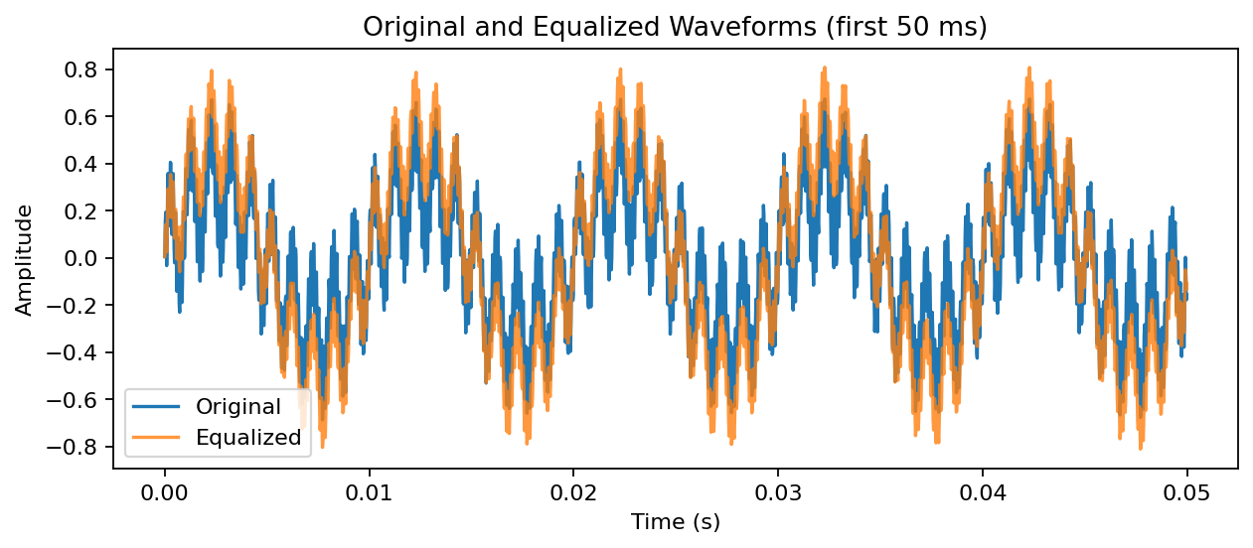
Figure 2: Original and equalized waveforms (illustrative plot from the described synthetic signal).
The time-domain comparison shows how the combined gains change sample amplitudes. Bass boosting increases the contribution of low-frequency components, while treble attenuation reduces the contribution of high-frequency components.

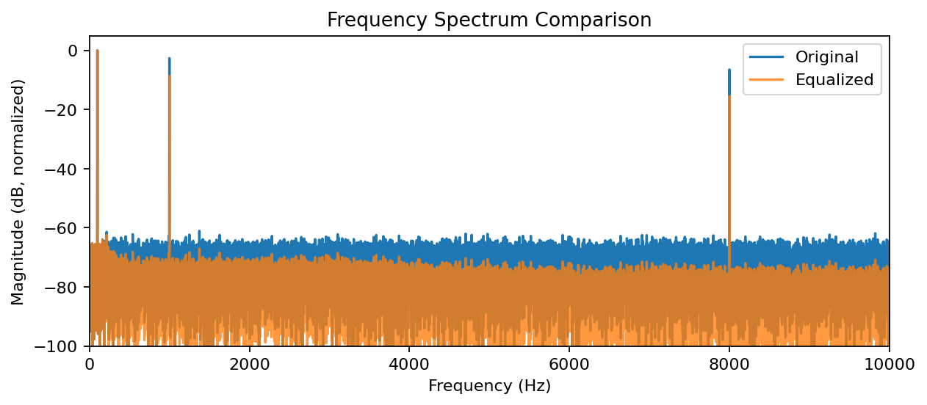
Figure 3: Frequency spectrum comparison.
The spectrum displays the relative frequency content of the input and equalized output. The test signal has prominent components near 100 Hz, 1 kHz, and 8 kHz. The gain settings are intended to increase the bass contribution and reduce the treble contribution.

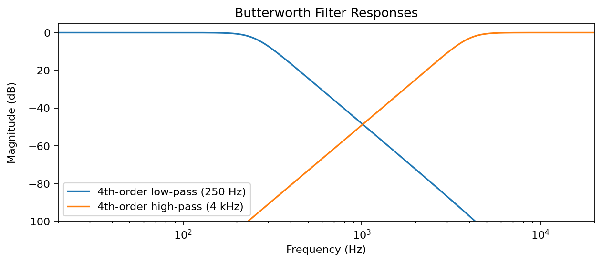
Figure 4: Butterworth low-pass and high-pass filter responses.
The low-pass response passes low frequencies and attenuates frequencies above its cutoff region. The high-pass response attenuates lower frequencies and passes frequencies above its cutoff region.

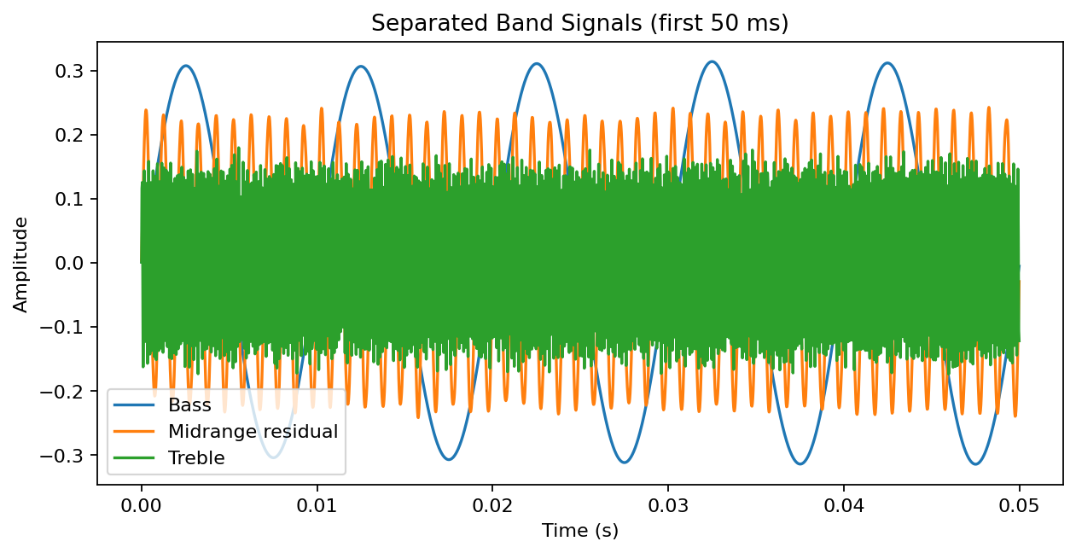
Figure 5: Separated bass, residual midrange, and treble branches.
The separated branches show the signal contributions used to construct the output. Because the midrange is computed as a residual, the unmodified branches add back to the original input, subject to numerical precision.

5.2 Performance Metrics
The following reference values are stated in the supplied DSP mini-project report. They were computed using Python SciPy with the same filter concept and gain settings; they should be verified against the values printed by the user's MATLAB run.
Metric | Reference value
Sampling rate | 44,100 Hz
Duration | 5.000000 s
Number of samples | 220,500
Bass gain | +6 dB
Midrange gain | 0 dB
Treble gain | −3 dB
Input RMS amplitude | 0.298721
Output RMS amplitude | 0.416026
Input peak amplitude | 0.850000
Output peak amplitude | 1.000000
Input crest factor | 2.845462
Output crest factor | 2.403697
RMS amplitude represents the effective average signal magnitude. Peak amplitude is the largest absolute sample. Crest factor is peak amplitude divided by RMS amplitude. The increase in RMS in the reference results is consistent with the selected bass boost, while the reduced crest factor indicates that the output RMS is larger relative to its peak. These values are not a subjective audio-quality score.

5.3 Comparison with Expected Results
Expected behaviour: the 100 Hz component should be primarily represented in the bass branch; the 1 kHz component should be primarily represented in the residual midrange; and the 8 kHz component should be primarily represented in the treble branch. Applying +6 dB to bass should increase that branch's amplitude by approximately a factor of 1.995. The midrange gain of 0 dB leaves its amplitude unchanged, and −3 dB scales the treble branch by approximately 0.708. The final result depends on the filter responses, residual-band construction, and any output normalization.

5.4 Observations and Analysis
- The equalizer provides independent control over three broad frequency regions.
- Butterworth filters provide smooth magnitude responses without passband ripple.
- The residual midrange makes the three unmodified branches sum to the original signal.
- The frequency spectrum helps show the relative change in frequency components after gain adjustment.
- RMS and peak measurements provide quantitative descriptions of the processed signal, but do not directly measure perceived quality.
- Forward-backward filtering with filtfilt is appropriate for offline analysis but is not a direct solution for real-time streaming.

5.5 Validation and Verification with Summary of Findings
The project structure and processing sequence are consistent with a basic offline three-band equalizer. The sample count is consistent with a duration of five seconds at 44.1 kHz. The dB-to-linear gain formula produces the intended bass boost and treble attenuation. The plots provide visual checks of the waveform, spectrum, filter responses, and band signals. The exact numerical results must be verified by running the MATLAB implementation because the supplied metrics are reference values and implementation or normalization details can change them.

CHAPTER 6: FUTURE ENHANCEMENT
The Digital Audio Equalizer Using MATLAB project can be further improved by incorporating advanced digital signal processing techniques and additional features to make the system more efficient, flexible, and user-friendly. The following enhancements can be considered for future development:
- Real-Time Audio Processing: The system can be extended to process live audio signals through a microphone or audio input device. This would allow users to hear the equalization effects instantly while adjusting the frequency bands.
- Graphical User Interface (GUI): A user-friendly graphical interface can be developed using MATLAB App Designer. It can include sliders for bass, midrange, and treble adjustment, buttons for loading and playing audio files, and controls for displaying input and output waveforms.
- Increasing the Number of Frequency Bands: The existing three-band equalizer can be extended to a five-band, seven-band, or ten-band equalizer. This would provide more precise control over different frequency ranges and improve flexibility in sound adjustment.
- Advanced Filter Design: Different digital filter types, such as Chebyshev, elliptic, and FIR filters, can be implemented and compared with the existing Butterworth filters. Their performance can be evaluated in terms of frequency response, computational complexity, and signal quality.
- Automatic Equalization: An automatic equalization feature can be introduced to analyze the input audio signal and adjust the gain of different frequency bands according to predefined criteria or the characteristics of the audio.
- Noise Reduction and Audio Enhancement: Noise reduction techniques can be integrated to minimize unwanted background noise and improve the clarity of audio signals, particularly in speech and recording applications.
- Performance Optimization: The algorithm can be optimized to reduce computational requirements and processing delay. This would make the equalizer more suitable for real-time applications and systems with limited processing resources.
- Hardware Implementation: The developed algorithm can be implemented on digital signal processors, microcontrollers, or other embedded platforms to create a practical audio equalizer for use in audio devices and multimedia systems.
In conclusion, these future enhancements can transform the basic three-band equalizer into a more advanced and interactive audio processing system. The integration of real-time processing, an improved user interface, advanced filtering techniques, and automatic gain control would increase its practical usefulness in music systems, speech processing, multimedia applications, and professional audio equipment.

CHAPTER 7: CONCLUSION AND RECOMMENDATIONS

7.1 Conclusion
The project “Digital Audio Equalizer Using MATLAB” successfully demonstrates the basic principles of Digital Signal Processing (DSP) through the design and implementation of a three-band digital audio equalizer. The primary objective of the project is to separate an audio signal into low-frequency (bass), mid-frequency (midrange), and high-frequency (treble) components and adjust their respective gain levels to modify the characteristics of the output signal.
The system uses fourth-order Butterworth filters for frequency-band separation. A low-pass filter with a cutoff frequency of 250 Hz is used to extract the bass component, while a high-pass filter with a cutoff frequency of 4 kHz is used to extract the treble component. The midrange component is obtained by subtracting the bass and treble components from the original input signal. The three components are then processed independently by applying suitable gain values and recombined to generate the equalized output signal.
The equalizer is configured with a bass gain of +6 dB, a midrange gain of 0 dB, and a treble gain of −3 dB. These settings demonstrate how low-frequency components can be enhanced, midrange components maintained, and high-frequency components reduced. MATLAB provides an effective environment for implementing the algorithm, designing digital filters, generating test signals, and analyzing the results through time-domain waveforms, frequency spectra, and filter-response plots.
The use of a synthetic test signal containing frequency components at 100 Hz, 1 kHz, and 8 kHz helps demonstrate the intended operation of the equalizer across the three frequency regions. Performance indicators such as root mean square (RMS) amplitude and peak amplitude can be used to evaluate changes between the input and output signals. The graphical analysis also helps visualize the effects of filtering and gain adjustment on the signal.
Overall, this project provides practical knowledge of digital filter design, frequency-band decomposition, gain control, and audio signal reconstruction. It also demonstrates the importance of MATLAB as a simulation and analysis tool for DSP applications. The developed system serves as a foundation for more advanced audio processing systems used in music playback, multimedia applications, speech processing, and sound enhancement.

7.2 Recommendations
Based on the design and implementation of the project, the following recommendations are proposed for improving the system and extending its practical applications:
- Real-Time Implementation: The equalizer should be extended to process live audio signals through a microphone or audio input device so that the effects of gain adjustment can be observed immediately.
- Graphical User Interface: A simple and interactive graphical user interface can be developed using MATLAB App Designer. It can provide sliders for adjusting bass, midrange, and treble levels, along with controls for loading, playing, and analyzing audio files.
- Additional Frequency Bands: The three-band equalizer can be expanded into a five-band, seven-band, or ten-band equalizer to provide more precise control over the audio frequency spectrum.
- Comparison of Filter Techniques: Butterworth filters can be compared with FIR, Chebyshev, and elliptic filters to study their frequency responses, computational requirements, and suitability for different audio applications.
- Audio Quality Evaluation: Further testing should be conducted using different types of real audio signals, including music and speech recordings. The output should be evaluated through waveform analysis, spectral analysis, RMS measurements, and listening tests.
- Noise Reduction: Noise suppression and audio enhancement techniques can be incorporated to improve sound clarity in environments containing unwanted background noise.
- Performance Optimization: The algorithm can be optimized to reduce processing time and delay, particularly when it is intended for real-time operation.
- Hardware Implementation: The equalizer can be implemented on a digital signal processor or a suitable embedded platform to evaluate its performance in practical audio devices.

7.3 Final Recommendation
It is recommended that the developed MATLAB-based equalizer be used as a foundation for further study and development in digital audio processing. Future work should focus on real-time implementation, an interactive interface, improved filter design, and testing with actual audio recordings. The output graphs and performance measurements should be verified using the executed MATLAB program to ensure that the reported results accurately represent the system's behavior.
With these improvements, the project can be extended from a basic simulation into a more practical and flexible audio equalization system. It provides a useful learning platform for understanding DSP concepts and their application in modern audio technology.

REFERENCES / BIBLIOGRAPHY
- Proakis, J. G., & Manolakis, D. G. (2007). Digital Signal Processing: Principles, Algorithms, and Applications (4th ed.). Pearson Prentice Hall.
- Oppenheim, A. V., Schafer, R. W., & Buck, J. R. (1999). Discrete-Time Signal Processing (2nd ed.). Prentice Hall.
- Smith, S. W. (1997). The Scientist and Engineer's Guide to Digital Signal Processing. California Technical Publishing.
- MathWorks. MATLAB Documentation. Available at: https://www.mathworks.com/help/matlab/
- MathWorks. Signal Processing Toolbox Documentation. Available at: https://www.mathworks.com/help/signal/
- MathWorks. Digital Filter Design. Available at: https://www.mathworks.com/help/signal/ug/digital-filter-design.html
- MathWorks. Butterworth Filter Design. Available at: https://www.mathworks.com/help/signal/ref/butter.html
- MathWorks. Frequency Response of Digital Filters. Available at: https://www.mathworks.com/help/signal/ref/freqz.html
- Lyons, R. G. (2011). Understanding Digital Signal Processing (3rd ed.). Pearson.
- Mitra, S. K. (2011). Digital Signal Processing: A Computer-Based Approach (4th ed.). McGraw-Hill.
- MATLAB documentation and tutorials on digital filtering, signal generation, frequency-domain analysis, and audio signal processing, available at: https://www.mathworks.com/help/
- Course notes and classroom materials on Digital Signal Processing provided by the Department of Computer Engineering and Technology, DES Pune University.
Note: The above references provide background information on digital signal processing, Butterworth filters, MATLAB implementation, and frequency-response analysis. Include only the books, documentation pages, and course materials actually consulted while completing the project. Access dates may be added for online references if required by the university's report format.

